Dit is een eerste test met Word bestand.

$ git status

On branch main

Your branch is ahead of 'origin/main' by 1 commit.

(use "git push" to publish your local commits)

Changes not staged for commit:

(use "git add <file>..." to update what will be committed)

(use "git restore <file>..." to discard changes in working directory)

modified: README.md

no changes added to commit (use "git add" and/or "git commit -a")

hazen@Flip MINGW64 /c/users/hazen/Documents/GitErik/TestErik01 (main)

$ git add .

hazen@Flip MINGW64 /c/users/hazen/Documents/GitErik/TestErik01 (main)

$ git status

On branch main

Your branch is ahead of 'origin/main' by 1 commit.

(use "git push" to publish your local commits)

Changes to be committed:

(use "git restore --staged <file>..." to unstage)

new file: Git Test 01.docx

modified: README.md

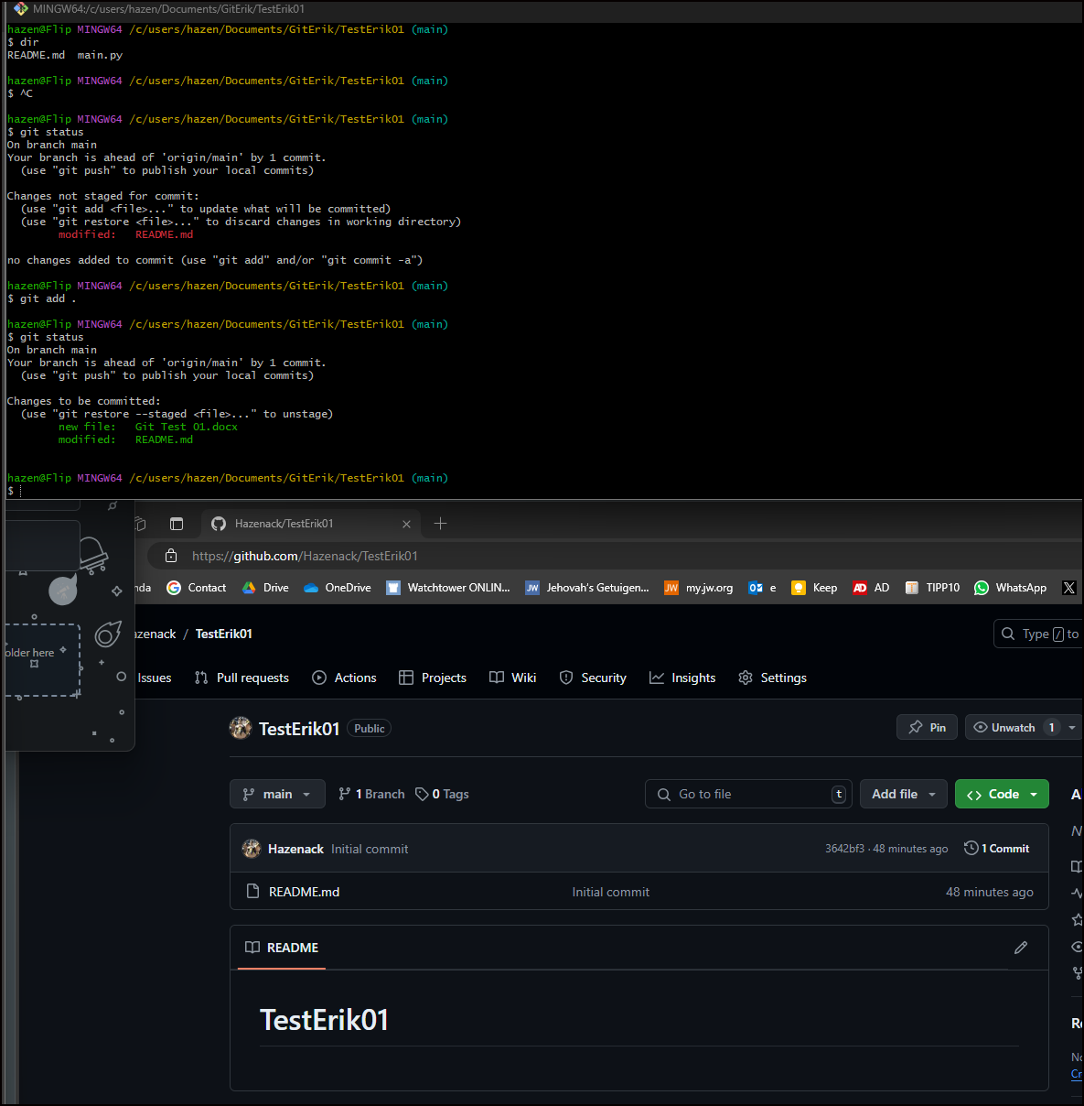

NU DE EERSTE COMMIT, MET WORD

hazen@Flip MINGW64 /c/users/hazen/Documents/GitErik/TestErik01 (main)

$ git commit -m "first commit"

[main 68b534d] first commit

2 files changed, 2 insertions(+), 1 deletion(-)

create mode 100644 Git Test 01.docx